Error Handling in GitHub Actions

What should the pipeline do when a step fails?
By default, if a step fails, GitHub Actions stops the remaining steps in that job
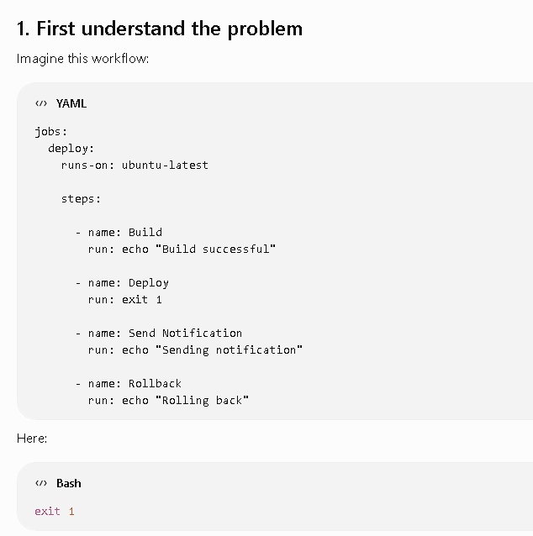
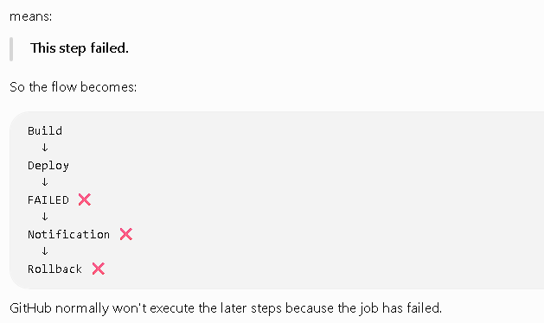
2. We can control this with if:
GitHub Actions provides status functions.
The important three from your document are:
success()
failure()
always()
3. failure()
Use:
if: failure()
when you want a step to execute after something has failed.
Example:
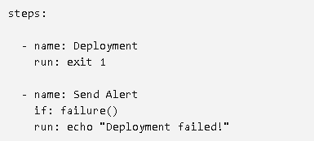
Flow:
Deployment
↓
FAILED ❌
↓
Send Alert
↓
"Deployment failed!"
This is particularly useful for:
- Sending alerts
- Logging failures
- Rollbacks
- Cleanup after failure
###
4. always()
if: always()
means:
Run this step regardless of whether previous steps succeeded or failed.
Example:
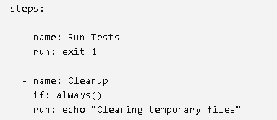
Even though testing fails:
Run Tests
↓
FAILED ❌
↓
Cleanup
↓
Runs anyway ✅
5. success()
if: success()
means:
Run only when the previous steps have succeeded.
This is also the default behavior for normal steps.
6. Simple Lab
Let's create a very simple workflow.
In your GitHub repository:
workflow-call-lab
│
└── .github
└── workflows
└── error-handling.yml
Create:
.github/workflows/error-handling.yml
name: Error Handling Demo
on:
push:
jobs:
error-demo:
runs-on: ubuntu-latest
steps:
- name: Step 1 - Success
run: echo "Step 1 completed successfully"
- name: Step 2 - Deployment
run: |
echo "Starting deployment..."
exit 1
- name: Step 3 - Failure Alert
if: failure()
run: echo "ALERT: Deployment failed!"
- name: Step 4 - Cleanup
if: always()
run: echo "Cleaning temporary files"
